10.RECRUITMENT SYSTEM

DEPLOYMENT DIAGRAM

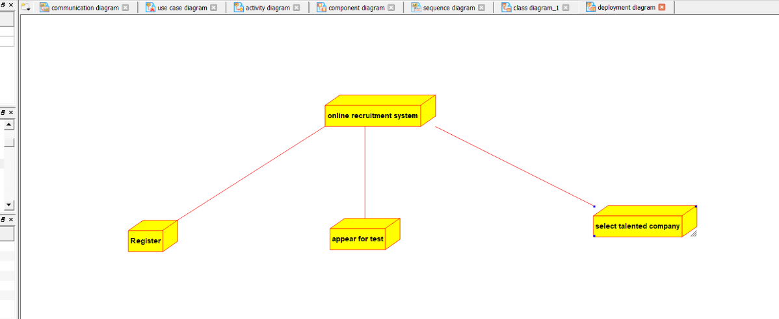

SEQUENCE DIAGRAM

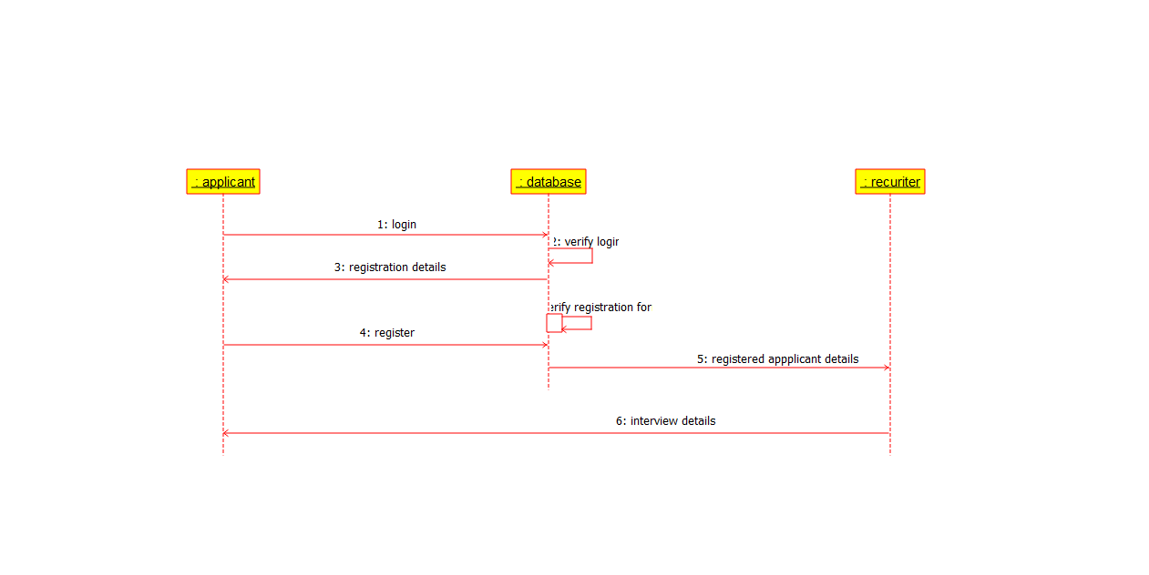

CLASS DIAGRAM

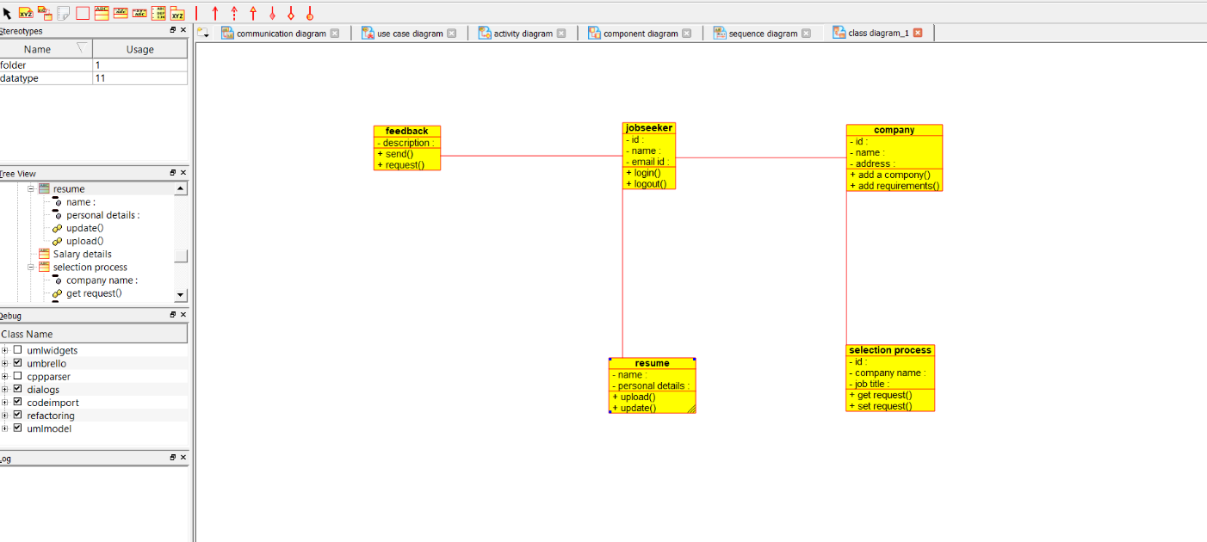

COLLABORATION DIAGRAM

